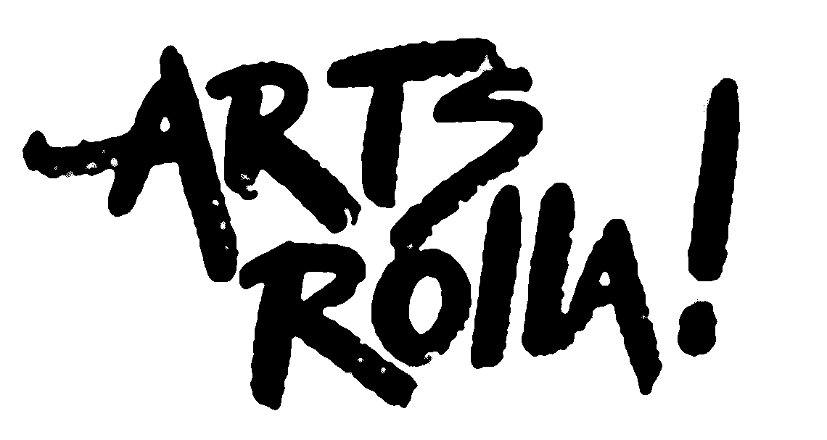

BLACK & WHITE ART SHOW
AUGUST 2024
Call for Art
ARTS ROLLA invites you to submit your original art for an exhibit which will be held
during the month of August, at THE CENTRE: Rolla’s Health & Recreation Complex located at 1200 N. Holloway, Rolla, MO.
This exhibit will feature original artworks created by Missouri artists.
This includes Drawing, Painting, Mixed Media, Jewelry, Sculpture, and Photography
- Artwork will be accepted on Tuesday, July 30, 2024, from 10 a.m. - 2 p.m.
- First Friday Opening August 2, 2024 from 5 p.m. - 7 p.m.
- Artwork must be picked up Tuesday, August 27, 2024, from 10 a.m. - 2 p.m.

Requirements: Must be a Member of Arts Rolla.
Only ORIGINAL, artworks will be accepted. No commercial or teacher-made patterns. No commercial crafts. Artists may submit up to 4 pieces or 2 Small Groupings of original work. Hanging art can be no larger than 36” x 36” or 144” total diameter. All artwork must be properly wired across the back for hanging. For proper hanging, the wires should be on the top third of the artwork. NO Sawtooth Hangers or Tape of ANY kind, will be allowed for hanging. 3-D art should be no larger than 24” and able to fit in the glass cabinets at The Centre. Stands for 3-D must be supplied by artist. 3-D sculpture may also be submitted; however, these works must be able to stand on their own and cannot be easily tipped.
Your name, the title of the artwork, phone number, price, and medium must be on the back of each piece of artwork when submitted. Items entered in the show may be photographed and shared in press releases, on the Arts Rolla website and Facebook page to help promote the arts, the artist and Arts Rolla ..
Entry fee: FREE – Artists must be a member of Arts Rolla to submit art for this exhibit. .
Arts Rolla will collect a 20% commission on all artwork sold.
A $10.00 handling fee is charged on artwork not claimed on the last day of the exhibit.
After one month, unclaimed art will become the property of Arts Rolla.
Contact Arts Rolla with questions or if you need to make special arrangements regarding
the pick up of your art. .

THE CENTRE provides general security; Arts Rolla handles artwork with care; therefore, they will not be held responsible for damage or theft during the exhibit.
THE CENTRE and Arts Rolla reserve final approval of all artwork to be displayed.
Contact Arts Rolla at 573-364-5539 or rtsrolla@gmail.com if you have questions.
Members, volunteers, and donations are greatly appreciated. Volunteers help with exhibits, receptions, and other activities scheduled throughout the year.
Membership in Arts Rolla is available to anyone with an interest in the arts.

2024 BLACK & WHITE
Art Show
ENTRY FORM
Date: _______________________ Artist’s Signature: _____________________________
The undersigned Artist agrees to the guidelines and conditions of entry and gives Arts Rolla permission to publish photographs of ALL the art entered in the show and to be included on the Arts Rolla Facebook page, and Arts Rolla website.

Entry Form: Please label the back or bottom of each piece of artwork with the required information shown below. This portion IS the entry form. Completed entry form must be given to the intake volunteer when submitting art. Information from this form will be used
for exhibitor list.

Name: _________________________________ Phone #_______________________________________

Address: _______________________________ Email: ________________________________________

City: _______________________ State: _____________ Zip Code: ___________________

Title of Artwork: 1) _________________________ Title of Artwork: 2) _____________________________

Medium: ___________________ Price: _________ Medium: ________________________ Price: _________

Title of artwork: 3) _________________________ Title of artwork: 4) _______________________________

Medium: ___________________ Price: _________ Medium: _________________________ Price: _________
